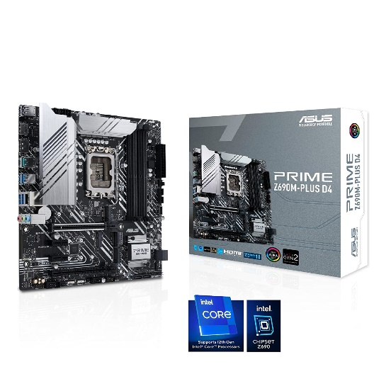

Inner

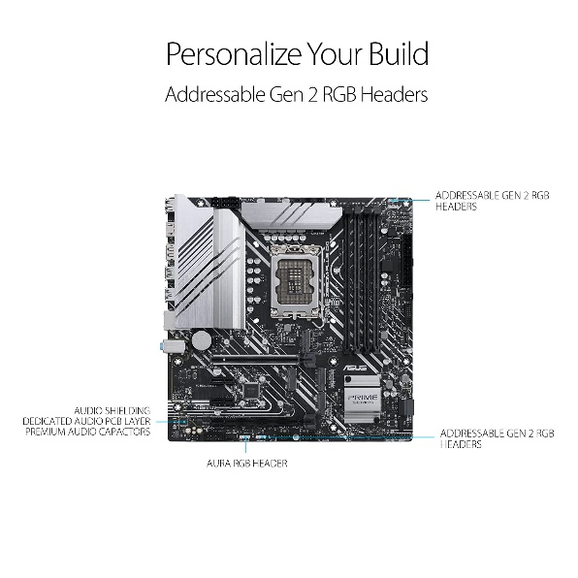

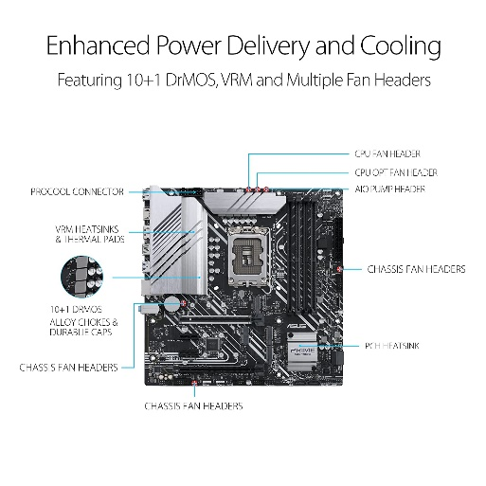

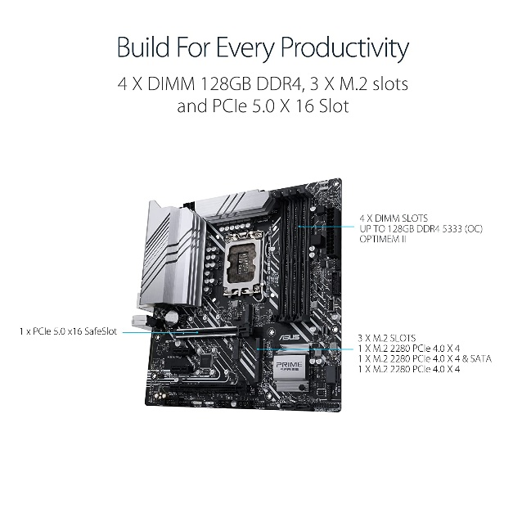

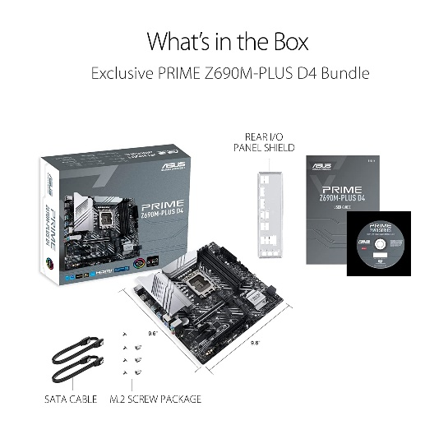

ASUS Prime Z690M-PLUS D4 LGA 1700 12th Gen Intel Core mATX Motherboard with PCIe 5.0, 3 M.2 Slots, DDR4, 1 Gb LAN, HDMI, USB 3.2 Gen2 Type-C, Front USB 3.2..

|  |  |
| --- | --- |
| M.R.P.: | ₹22,000.00₹22,000.00 |
| Deal of the Day: | ₹18,599.00₹18,599.00 |

|  |  |
| --- | --- |
| Brand | ASUS |
| CPU Socket | LGA 1700 |
| Compatible Devices | Personal Computer |
| RAM Memory Technology | DDR4 |
| Compatible Processors | 12th Gen Intel Core, Pentium Gold and Celeron Processors |

**About this item**

* Coupled with HD lens and the camera has auto white balance and auto exposure.It captures clear 1080P at 30fps video, and when you move from dark to light areas, the auto exposure does its job as well
* Wifi Camera Control the camera via your smart phone,use the WiFi function of the camera to watch live in phone video, Audio and photos to your smartphone
* FHD HD Security Camera provides you with an enough clear picture to see the situation anywhere on APP. The WIFI camera providing wider viewing angle greatly reduces the blind area.The black infrared lights offer a 10ft visible range in the dark, giving you a super night vision experience
* The Motion Detect option.Tough and durable designï¼?It's slim enough that it will fit nicely in a pocket
* Built-in 1800mAh rechargeable battery, charging time about 2 hours, recording time(in 1080P, wifi off) about 4-5 hours, makes 2hours recording for 32GB, and 4hours for 64GB, Meanwhileï¼?the camera support charging and record at the same time

s